Report

IT-562 Recommendation Engine

Team-Kitkat

The algorithm we have used here to calculate the RMSE and MAE value is SVD. We have used the inbuilt implementation of SVD from surprise library. So here we have divided our data into 5 folds i.e. we have 5 parts of data out of which 4 will be used to train the dataset and the remaining ones will be used for testing and calculate RMSE and MAE value. Initially, we have calculated RMSE and MAE value for 1000 tuples then for 10000, 21633, 100000 and finally for 836006. The code snippet that we have used is as below.

**CODE:**

import os

import surprise

from guppy import hpy

from surprise import BaselineOnly

from surprise import Dataset

from surprise import Reader

from surprise import SVD

from surprise.model_selection import cross_validate

# path to dataset file

if __name__ == '__main__':

file_path = os.path.expanduser('C:/Users/admin/Desktop/Data/music/ratings_digital_music(full).csv')

reader = Reader(line_format='user item rating timestamp', sep=',')

data = Dataset.load_from_file(file_path, reader=reader)

algo = SVD()

cross_validate(algo, data, measures=['RMSE', 'MAE'], cv=5, verbose=True)

h = hpy()

print h.heap()

In the above code, we have taken input from a CSV file. The dataset that we have used has user_id, song_id, ratings and timestamp as their columns.

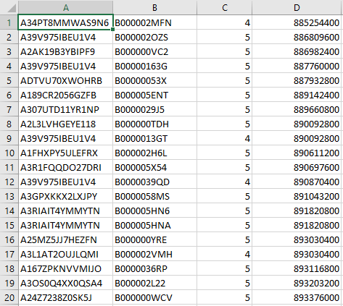

**Output:**

For 1000 tuples.

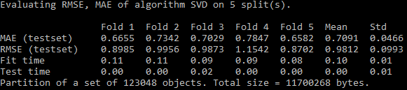

For 10000 Tuples.

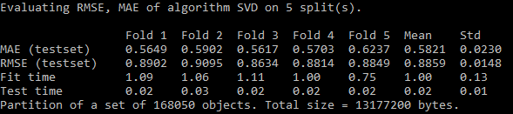

For 21633 tuples

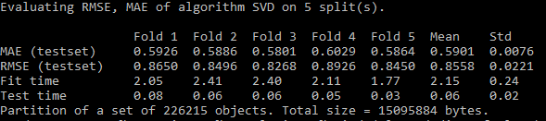

For 100000 tuples

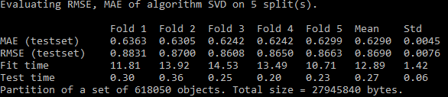

For 836006 tuples

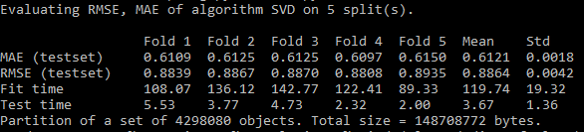

In all the Graphs below 1(on x-axis) corresponds to 1000 tuples, Similarly

2- 10000

3 - 21633

4 - 100000

5 - 836006

So, while plotting graphs we will take mean RMSE into consideration.

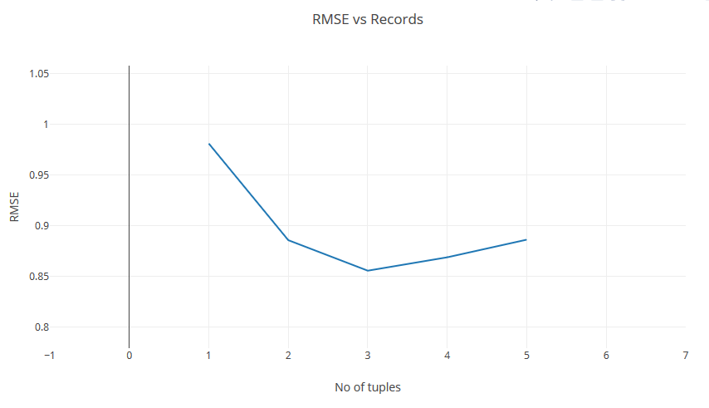

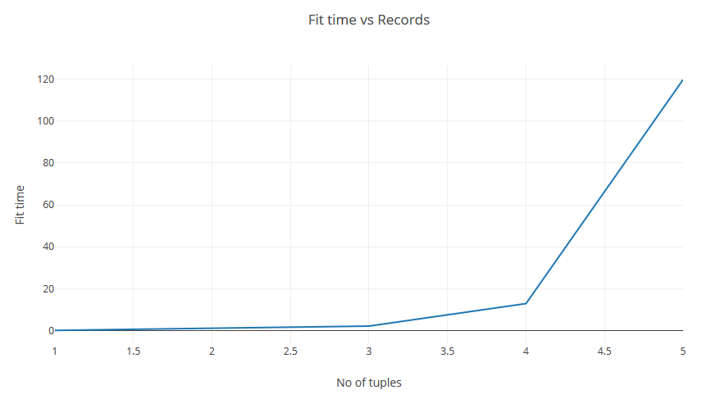

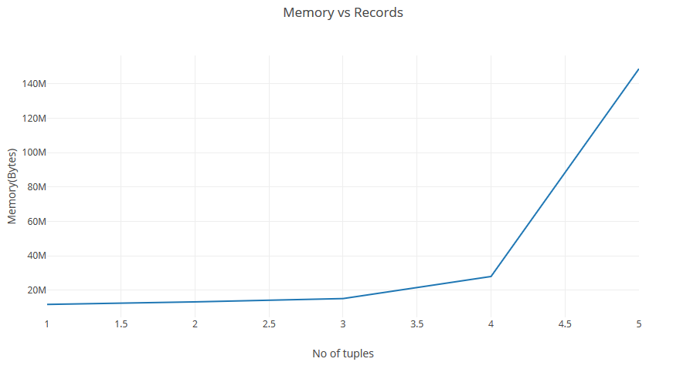

Thus from above results we can conclude that it is not necessary that with the increase in training data the error would decrease factors like number of folds, how the partition of data is done also plays a very important role.